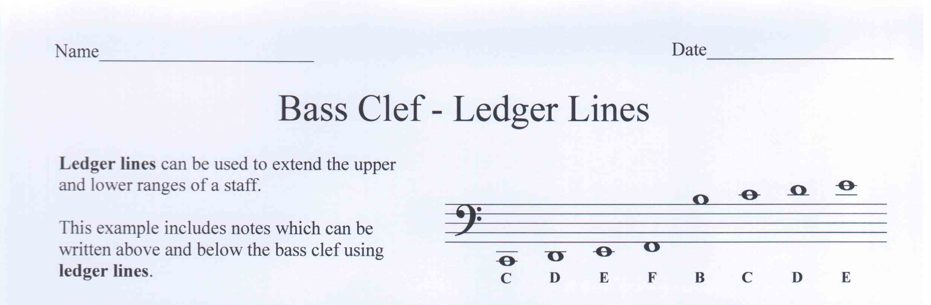

Fill in the letter name of each note.

C
B
E
F
B
E
C
G

F
D
G
E
B
F
C
B
C
E

What is another name for the bass clef?

What does a bar line do?

